# Storage queues and Service Bus queues

## Introduction

**# Storage queues**

**Azure Queue storage**

• Azure Queue storage is an Azure service that implements cloud-based queues.

• Each queue maintains a list of messages.

• Application components access a queue using a REST API or an Azure-supplied client library.

• Typically, you will have one or more sender components and one or more receiver components.

• Sender components add messages to the queue. Receiver components retrieve messages from the front of the queue for processing.

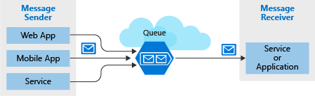

**Message**

• A message in a queue is a byte array of up to 64 KB.

• Message contents are not interpreted at all by any Azure component.

• If you want to create a structured message, you could format the message content using XML or JSON.

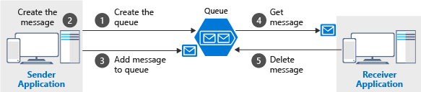

**# Service Bus**

• Azure Service Bus can exchange messages in three different ways: queues, topics, and relays.

**Queue**

• A queue is a simple temporary storage location for messages.

• A sending component adds a message to the queue. A destination component picks up the message at the front of the queue.

• Under ordinary circumstances, each message is received by only one receiver.

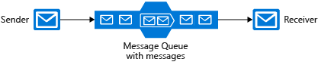

**Topic**

• A topic is similar to a queue but can have multiple subscriptions.

• This means that multiple destination components can subscribe to a single topic, so each message is delivered to multiple receivers.

• Subscriptions can also filter the messages in the topic to receive only messages that are relevant. • Subscriptions provide the same decoupled communications as queues and respond to high demand in the same way.

• Use a topic if you want each message to be delivered to more than one destination component.

Note

• Topics are not supported in the Basic pricing tier.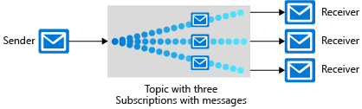

**Relay**

• A relay is an object that performs synchronous, two-way communication between applications.

• Unlike queues and topics, it is not a temporary storage location for messages.

• Instead, it provides bidirectional, unbuffered connections across network boundaries such as firewalls.

• Use a relay when you want direct communications between components as if they were located on the same network segment but separated by network security devices.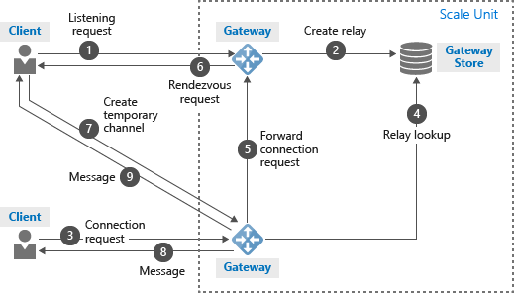

**Note**

• An Azure Service Bus queue message must be larger than 64 KB but smaller than 256 KB

## Advantages

**# Storage queues**

Advantages of storage queues:

• Supports unlimited queue size (versus 80-GB limit for Service Bus queues)

• Maintains a log of all messages

**# Service Bus**

Key advantages of Service Bus queues include:

• Supports larger messages sizes of 256 KB (standard tier) or 1MB (premium tier) per message versus 64 KB

• Supports both at-least-once and at-most-once delivery - choose between a very small chance that a message is lost or a very small chance it is handled twice

• Guarantees first-in-first-out (FIFO) order - messages are handled in the same order they are added (although FIFO is the normal operation of a queue, it is not guaranteed for every message)

• Can group multiple messages into a transaction - if one message in the transaction fails to be delivered, all messages in the transaction will not be delivered

• Supports role-based security

• Does not require destination components to continuously poll the queue

## Comparison

**# Storage queues**

**Consider using Storage queues when:**

• Your application must store over 80 GB of messages in a queue.

• Your application wants to track progress for processing a message inside of the queue. This is useful if the worker processing a message crashes. A subsequent worker can then use that information to continue from where the prior worker left off.

• You require server side logs of all of the transactions executed against your queues.

**# Service Bus**

**Consider using Service Bus queues when:**

• Your solution must be able to receive messages without having to poll the queue. With Service Bus, this can be achieved through the use of the long-polling receive operation using the TCP-based protocols that Service Bus supports.

• Your solution requires the queue to provide a guaranteed first-in-first-out (FIFO) ordered delivery.

• Your application handles messages that can exceed 64 KB but will not likely approach the 256 KB limit.

• Your queue size will not grow larger than 80 GB.